**About the ESOL Program at the School Sisters of Notre Dame Educational Center**

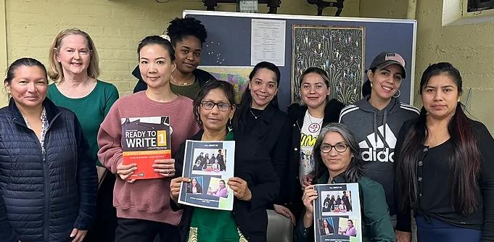

**What is ESOL?**

* ESOL (English for Speakers of Other Languages) is a program designed to strengthen the reading, writing, listening, and speaking skills in English in people for whom English is not their native language.

**About ESOL at the School Sisters of Notre Dame Educational Center**

* The ESOL program at the SSND Educational Center provides classes for students with six levels of proficiency in English.
* Classes include Introductory Level, Levels 1 through Level 5/Advanced Conversation, and Beginning and Intermediate Writing via Zoom. A student’s class is based on her fluency in English.
* There is a $40 fee to register each year. There are no costs for classes or books.
* All classes are in person, except for the Writing Classes via Zoom.
* Most classes use the Ventures textbook series. This series focuses on practical topics such as personal information, school, health, family and friends, and the local community.

**Eligibility for attending the School Sisters of Notre Dame Educational Center ESOL program:**

* Women must be at least 21 years old. Classes are for women only.
* Classes are Monday through Thursday. Classes meet two or three times a week. Different levels of class meet on different days and at different times.
* To determine the appropriate level of instruction for a student, students take a placement test. Placement tests are normally given three times a year: in September/October, January, and June.

**I want to take English classes at the Center. What should I do?**

Take the placement test:

* **Come to the Educational Center on Thursday, June 20, 2024 at 10:00 a.m. for the placement test.**  Please be on time for the test.
* You must be 21 years old or older to take the test.
* The test will take approximately 1½ hours.
* You do not need to bring anything with you to the test.
* Do not bring children with you to the test.

After you take the placement test, you can register.

* You will come back to the Center on Friday, June 21, 2024 at 10:00 a.m. to register for your class. When you register, we will tell you the level of your class and the time and days your class will meet.
* Bring a registration fee of $40 with you.
* Classes will begin on September 16 or 17, 2024, depending on the class level.

**Interested in finding out more about the ESOL program at the School Sisters of Notre Dame Educational Center? Do you have specific questions of concerns?**

* Send an email with your questions or concerns to Cathy Stare, the SSND Center registrar, at [cathy.stare@ssndecwomens.org](mailto:cathy.stare@ssndecwomens.org).

**Description of ESOL Classes:**

* The basic literacy skills of reading, writing, listening, and speaking in English are taught at each level of instruction.
* Conversation is an important focus of instruction. Students develop fluency in English as they converse about practical topics such as shopping, health, and daily living.
* As students progress from one level of instruction to another, they strengthen their writing skills. In the Introductory level, students learn the alphabet and write simple sentences. In each succeeding level, students write more complex sentences. By the time they are in Level 5 or a Zoom writing class, students are able to write short compositions.