**About the GED Program at the School Sisters of Notre Dame Educational Center**

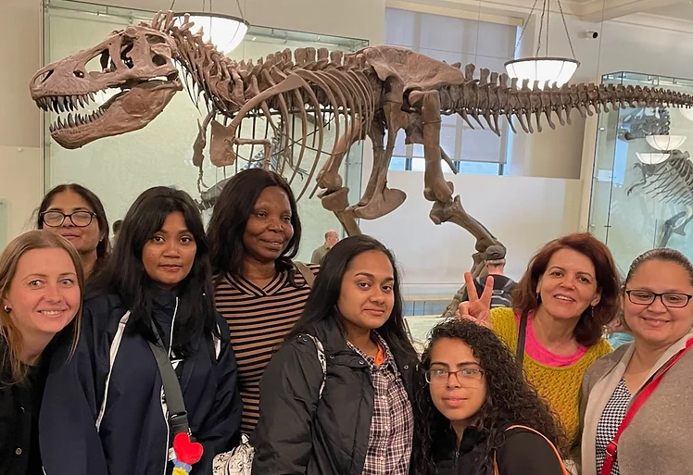

**What is the GED?**

The GED (General Educational Development) test is the test used by New York State to issue high school equivalency diplomas.

**About the GED:**

The GED test requires students to take and pass subtests in four subject areas: English, math, science, and social studies. All information about the GED, including ways to study, practice questions, when and where the test is offered, and how to sign up to take the test, can be found at <https://ged.com/>.

**About the GED program at the School Sisters of Notre Dame Educational Center:**

The School Sisters of Notre Dame Educational Center, located at 87-04 88th Avenue in Woodhaven, NY, provides classes to prepare women to take the GED test. Classes are small and the environment is welcoming and supportive.

* Classes are offered Monday through Thursday, 9:00 a.m. to 1:30 p.m.
* Classes are taught by certified teachers and are taught in English.
* Classes are offered in the following subjects: English, math, science, and social studies.
* There is a $40 fee to register each year. There is no cost for classes or books.
* Classes begin in September and continue until June.
* All classes are in person.

**Eligibility for attending the School Sisters of Notre Dame Educational Center program:**

Women must:

* Be committed to working on their high school equivalency diploma
* Be twenty years old or older (no upper limit)
* Be able to attend classes Monday through Thursday, 9:00 a.m. to 1:30 p.m.
* Have the background in English and mathematics to work on the high school curriculum in English

**To register for GED classes that will begin in September 2024:**

* Come to the Center between 9:00 a.m. – 1:00 p.m. on one of the following dates:
* Tuesday, August 27
* Wednesday, August 28
* Monday, September 9
* Wednesday, September 11
* Thursday, September 12
* You will be given a short test in English and math as part of the registration process.
* There is a $40 registration fee each year. There is no fee for classes or books.
* Classes will begin on Monday, September 16, 2024 at 9:00 a.m.

**Frequently asked questions:**

* When do classes begin?
  + Classes begin in September. In 2024, classes will begin on Monday, September 16. However, students can join the program during the school year.
* I need to take only certain subjects, since I’ve already passes some of them. Can I attend this program?
* Yes. Several students who are in our program take only some classes because they have already passed the GED in some subject areas.
* Sometimes I’ll need to miss class. Is that ok?
  + Yes. We understand that life happens and students will need to be absent. Students are asked to contact the Center and let us know that they will miss class.
* Will we be using laptops and desktop computers in class?
  + Yes, laptops and desktop computers are used in class to facilitate learning and to prepare students to take the GED test which is done on computer.
* Is there a cost for the program?
  + Yes. There is a $40 fee to register. There is no cost for books or classes.
* Can I take the GED test at the Center?
* No. The GED test needs to be taken at a NYC HSE (High school Equivalency) Testing Center. We will help you find a testing center and register for the GED test. A list of testing centers can be found at <https://ged.com/>.
* What do I need to bring to class at the Center?
* You need to bring pens, pencils, notebooks, and folders. The most important things to bring, however, are your heart and your mind, your energy and perseverance, and your determination and desire to work hard and succeed.
* How long will I need to study at the Center?
* The length of time that women study at the Center depends on the amount of schooling they have already had, how quickly they learn, and how much time they can study on their own. As soon as students attain a sufficient level of proficiency in a subject area, their teacher will encourage them to register for the GED test in that subject.

**Interested in finding out more about the GED program at the School Sisters of Notre Dame Educational Center? Do you have specific questions of concerns?**

* Send an email with your questions or concerns to Cathy Stare, the GED registrar, at [cathy.stare@ssndecwomens.org](mailto:cathy.stare@ssndecwomens.org).

**About the GED in New York State:**

States have different requirements for granting a high school equivalency diploma. At the website <https://www.acces.nysed.gov/hse/high-school-equivalency-hse>, you can find further information that pertains to New York State residents. There you will see other pathways through which New York State residents can obtain a high school equivalency diploma.

Good news: There is no cost to take the GED test for New York State residents.

**Description of GED Classes:**

English: Students develop critical thinking skills that enable them to write a clear and analytical essay on a given topic. Students read passages and answer questions that demonstrate their reading ability.

Mathematics: Building on basic math skills, students study geometry, algebra, graphs, and functions.

Science: Students use logic and reasoning to interpret information and draw conclusions in a science context and to design and interpret science experiments.

Social Studies: Students learn to analyze historical events and arguments as well as read graphs to interpret social studies information.

Computer: Since the GED test is taken on computer, students use computers in class to practice writing their essay and answering a variety of types of questions.